Remotely Close Associations: Openness to Experience and Semantic Memory Structure

Alexander P. Christensen¹, Yoed N. Kenett², Katherine N. Cotter¹, Roger E. Beaty³, & Paul J. Silvia¹

¹ Department of Psychology, University of North Carolina at Greensboro, Greensboro, NC, 27402-6170, USA
² Department of Psychology, University of Pennsylvania, Philadelphia, PA, 19104 USA
³ Department of Psychology and Center for Brain Science, Harvard University, Cambridge, MA, 02138 USA

R.E.B. and P.J.S. were supported by grant RFP-15-12 from the Imagination Institute (www.imagination-institute.org), funded by the John Templeton Foundation. The opinions expressed in this publication are those of the authors and do not necessarily reflect the view of the Imagination Institute or the John Templeton Foundation.

Corresponding author:
Alexander P. Christensen
Department of Psychology, P. O. Box 26170
University of North Carolina at Greensboro, Greensboro, NC, 27502-6170, USA
Email: apchrist@uncg.edu
Abstract word count: 196
Word count:

Abstract
Openness to Experience—the enjoyment of novel experiences and ideas—has many connections to cognitive processes. People high in Openness to Experience, for example, tend to be more creative and have broader general knowledge than people low in Openness to Experience. In the current study, we use a network science approach to examine if the organization of semantic memory differs between high and low groups of Openness to Experience. A sample of 516 adults completed the NEO-FFI-3 and Big Five Aspect Scales’ Openness to Experience inventories and a semantic verbal fluency task. Next, the sample was split in half to form high (n = 258) and low (n = 258) Openness to Experience groups. Semantic networks were then constructed based on their verbal fluency responses. Our results revealed that the high Openness to Experience group’s network was more interconnected, flexible, and had better local organization of associations than the low Openness to Experience group. We also found that the high Openness to Experience group generated more responses on average and provided more unique responses than the low Openness to Experience group. Taken together, our results indicate that Openness to Experience is related to semantic memory structure.

Keywords: Openness to Experience, semantic memory, network analysis, semantic networks
Remotely Close Associations: Openness to Experience and Semantic Memory Structure
In the Big Five personality model, Openness to Experience is commonly found to be related to cognitive processes. In an examination of behavioral, affective, and cognitive processes related to Big Five personality traits, Openness to Experience was chiefly characterized by cognition (Zillig, Hemenover, & Dienstbier, 2002). Many studies link Openness to Experience to cognitive abilities such as intelligence, working memory, and creativity (DeYoung, Grazioplene, & Peterson, 2012; Kaufman et al., 2010; Kaufman et al., 2016). Few studies, however, have examined other cognitive factors, such as semantic memory (our knowledge about the word, such as word meanings, concepts, and categorizations of facts; McRae & Jones, 2013), that might contribute to these relationships (Jauk, Benedek, & Neubauer, 2014; Kwantes, Derbentseva, Lam, Vartanian, & Marmurek, 2016; Prabhakaran, Green, & Gray, 2014)
Recent computational research suggests that the structure of semantic memory could be a cognitive factor that underlies more general cognitive differences associated with Openness to Experience. Highly creative people, for example, exhibit more flexible, interconnected relations between concepts than less creative people (Kenett, Anaki, & Faust, 2014; Kenett et al., 2018). Likewise, people higher in fluid intelligence show greater structure (i.e., more order) in their semantic memory (Kenett, Beaty, Silvia, Anaki, & Faust, 2016). Given the links between Openness to Experience, creativity, and intelligence, the structure of semantic memory might be related to Openness to Experience. The present study thus examined the structure of semantic memory between groups of high and low Openness to Experience using a computational network science approach.
Openness to Experience, Cognition and Semantic Memory
Openness to Experience has many links to basic cognition. Perhaps the most established one is creative thought (Oleynick et al., 2017), to the point that “creativity” has been considered as an alternative label (Johnson, 1994). People high in Openness to Experience are described as original, unconventional, imaginative, intellectual, curious, and creative (Johnson, 1994; McCrae & Costa, 1997). Open people tend to seek out new experiences and to be more sensitive to novelty in experiences of interest and pleasure (Fayn, MacCann, Tiliopoulos, & Silvia, 2015; McCrae & Costa, 1997). Diverse experiences have been shown to enhance cognitive flexibility—the ability to break old cognitive patterns, overcome functional fixedness, and make novel associations between concepts (Guilford, 1967; Ritter et al., 2012)—which is a core component of creativity (Hennessey & Amabile, 2010). Indeed, Openness to Experience is the most consistent predictor of creative achievement in the arts and sciences (Feist, 1998; Kaufman et al., 2016).
In addition to creative output, open people’s engagement in a variety of experiences leads to the acquisition of broad general knowledge. The breadth and depth of this knowledge is acquired by formal and informal education as well as life experiences (McGrew, 2009). People higher in Openness to Experience are consistently found to have higher crystallized intelligence—the accumulation of knowledge over time, including language, information, and concepts of a specific culture (Ackerman & Heggestad, 1997; DeYoung et al., 2012; McGrew, 2009). They are also more likely to spend their time doing activities that encourage the accumulation of information such as reading all genres of literature for pleasure (Finn, 1997; McManus & Furnham, 2006). In general, open people tend to be curious and have a motivation to learn, which makes them more likely to explore and invest in many knowledge domains (Kashdan, Rose, & Fincham, 2004; Silvia & Sanders, 2010; von Stumm, 2018). Thus, people high in Openness to Experience actively attain information that contributes to general knowledge and semantic knowledge, more specifically.
To date, a handful of studies have implied a link between Openness to Experience and semantic memory. In one study, people high in Openness to Experience came up with more semantically distant verbs—determined via latent semantic analysis (LSA; Landauer & Dumais, 1997)—when cued to generate a creative verb for a noun (Prabhakaran et al., 2014). Interestingly, intelligence, working memory, and facets related to the Openness aspect of Openness to Experience—defined by perceptual and aesthetic engagement—were related to semantic distance but facets related to the Intellect aspect of Openness to Experience were not (DeYoung et al., 2012). In another study, Kwantes et al. (2016) applied LSA to assess the semantic content of people’s responses to scenarios that were associated with different Big Five personality traits—for Openness to Experience, the scenario was, “Where would you travel if you had an all-inclusive trip and why?”. The authors found that people higher in Openness to Experience used more words in their response that were related to the descriptors of Openness to Experience than people low in the trait (Kwantes et al., 2016). Finally, Openness to Experience is a consistent predictor of performance on semantic verbal fluency tasks—generating as many responses as they can for a single category—which taps the ability to recall semantic information stored in long-term memory (e.g., animals; Sutin et al., 2011). Given the evidence above, open people might differ in how they recall and use semantic information. Thus, investigating the structure of their semantic memory via semantic networks may offer a way to investigate these differences.
Semantic Network Analysis and Measurement
Recent research has applied network science tools to investigate cognitive phenomena such as the structure of language and memory (Baronchelli, Ferrer-i-Cancho, Pastor-Satorras, Chater, & Christiansen, 2013; Borge-Holthoefer & Arenas, 2010; De Deyne, Kenett, Anaki, Faust, & Navarro, 2016; Karuza, Thompson-Schill, & Bassett, 2016). In semantic networks, nodes represent concepts or words in memory and edges signify the relations between them (e.g. semantic similarity). By structuring language and memory as a network, network science can directly and quantitatively examine classic cognitive theory and the operations of cognitive processes that take place in memory retrieval and associative thought (Anderson, 1983; Baronchelli et al., 2013; Collins & Loftus, 1975). Cognitive networks, for example, have identified mechanisms of language development (Hills, Maouene, Maouene, Sheya, & Smith, 2009; Steyvers & Tenenbaum, 2005), shown how specific network parameters influence memory retrieval (Vitevitch, Chan, & Goldstein, 2014; Vitevitch, Chan, & Roodenrys, 2012; Vitevitch, Goldstein, & Johnson, 2016), and provided new insight on the semantic structure of second languages in bilinguals (Borodkin, Kenett, Faust, & Mashal, 2016).
A popular way of constructing semantic memory networks is based on verbal fluency tasks (Goñi et al., 2011; Kenett et al., 2013). Verbal fluency tasks present the participant with a single category for which they generate as many category exemplars as they can (Borodkin et al., 2016; Kenett et al., 2013). In both methods, participants are given a limited amount of time to generate their associations (usually 60 seconds). For this study, we constructed our semantic networks using a verbal fluency task (i.e., the animals category). While different semantic categories have been used for this task, the animal category is the most widely used, as it has a universal taxonomy (i.e., the animal kingdom) and has shown only minor differences across different languages and cultures (Ardila, Ostrosky‐Solís, & Bernal, 2006).
Semantic Network Terminology
Of the network models that have been developed in network science theory, the Small World Network model (SWN; Watts & Strogatz, 1998) has been one of the most widely used to examine complex systems. SWNs are defined by two main characteristics: the network’s clustering coefficient (CC) and its average shortest path length (ASPL). The clustering coefficient of a node refers to the extent that two neighbors of a node will themselves be neighbors (i.e., a neighbor is a node i that is connected through an edge to node j). In this way, the average clustering of the nodes in the network (referred to hereafter as CC) indicates how semantic information is organized at a local level (e.g., marine animals). A network with a higher CC suggests that exemplars that are near-neighbors to each other (e.g., fish-dolphin-whale-shark) tend to co-occur. For example, Borodkin, Kenett, Faust, and Mashal (2016) has shown how the CC of the second language in bilinguals is higher, attributed to less organized semantic networks compared to the organization of the semantic network of their first language.
The ASPL refers to the average shortest number of steps (i.e., edges) needed to traverse between any pair of nodes. In semantic networks, short path lengths indicate increased interconnectivity and smaller distances between concepts, which may relate to a greater ability to switch from one sub-category to another, with fewer mediating associations (e.g., cat-fish-dolphin compared to cat-dog-fish-whale-dolphin). According to the ACT model, lower ASPL might affect spreading activation—the activation of associations between concepts—and facilitate the search and retrieval of associations in memory (Anderson, 1983; Collins & Loftus, 1975). In this regard, Kenett, Levi, Anaki, and Faust (2017) have shown how shorter distances in a semantic network predict behavioral performance in a relatedness judgment task. Furthermore, higher creative ability has been related to lower ASPL (Benedek et al., 2017; Kenett et al., 2014). These studies have argued that the lower ASPL in the semantic network of high creative individuals may have contributed to their ability to generate more unique responses to target words than the less creative group (Kenett et al., 2014).
The final network measure, commonly used to quantify semantic networks, is modularity. Modularity identifies how a network breaks apart (or partitions) into smaller sub-networks or communities (Fortunato, 2010; Newman, 2006). The modularity statistic (Q) measures the extent to which the network has dense connections between nodes within a community and sparse (or few) connections between nodes in different communities. Thus, a network with a large Q would have more neatly compartmentalized (or more rigidly defined) communities in the network compared to a network with a small Q. In a semantic network, these communities might represent sub-categories of a larger category. The animal category, for example, might have sub-categories of pets, reptiles, insects, and marine animals (Goñi et al., 2011). Recent studies have highlighted the significance of modularity in cognitive networks in typical and clinical populations (Kenett, Gold, & Faust, 2016; Siew, 2013). For example, the semantic network of individuals with high functioning autism (Asperger’s syndrome) exhibits a higher modularity value than matched controls, which is attributed to their rigidity in processing creative language (Kenett, Gold, et al., 2016).
The Present Study
Our study is the first network analysis on the relation of Openness to Experience and semantic memory structure. We assessed Openness to Experience using two different inventories, the NEO-FFI-3 (McCrae & Costa, 2007) and BFAS, to capture a broad, comprehensive measurement of the trait. Because of Openness to Experience’s many relations to cognitive abilities, we removed items from both inventories that had obvious relations to self-assessed intelligence and cognitive ability (Mõttus, 2016; von Stumm, 2018). We then divided the sample in half to form groups of high and low Openness to Experience. Previous studies, using a similar semantic network, have found that highly creative people tend to have semantic network structures that are more interconnected (low ASPL) and flexible(low Q; Benedek et al., 2017; Kenett et al., 2014; Kenett, Beaty, et al., 2016). Because of Openness to Experience’s relationship with creativity, we predicted that the high Openness to Experience group’s semantic network would exhibited similar network properties, namely a lower ASPL and Q.
Methods
Participants
There were 516 participants in the current study who were included across three samples. The first sample was collected during the Fall 2015 semester through the University of North Carolina at Greensboro’s (UNCG) psychology research pool. PAUL SAMPLE SIZE WAS DETERMINED BY…. The total sample included 311 participants, but fifty-six participants were excluded due to missing fluency data, forty-one due to inattentive responding, and eight due to being non-native English speakers. The remaining sample consisted of 206 participants (54.9% Caucasian, 36.8% African American), who were primarily young adults (M = 19.16, SD = 3.33, 78.6% female, 15% male) enrolled in psychology courses. Participants were compensated with research credits for their participant in the study.
The second sample was collected during the Fall 2016 semester and Spring 2017 semester at UNCG. Sample size was pre-determined for the first author’s thesis, which required at least 200 people and ended data collection after the Spring 2017 semester concluded. A total of 262 participants were recruited using UNCG’s psychology research pool, of which sixty participants were excluded due to missing fluency data, twenty-one due to inattentive responding, and eight due to being non-native English speakers. The remaining sample consisted of 173 participants (53.2% Caucasian, 45.1% African American) who were primarily young adults (M = 18.61, SD = 1.10, 78.6% female, 20.2% male) and were enrolled in psychology courses. Participants were compensated with research credits for their participant in the study.
The third sample (N = 168) was obtained from an fMRI study (Beaty et al., 2018). Sample size was pre-determined based on a grant proposal, which anticipated recruiting 200 adults with recruitment ending after 2 years upon project start (Summer 2015 – Summer 2017). Participants were recruited from UNCG and its surrounding community using fliers around campus and local ads describing an fMRI study on creativity. This study had several common exclusion and inclusion criteria for neuroimaging research: participants must be right-handed, have no past psychiatric disorder, and cannot currently be taking any medication. Participants were excluded if any of these restrictions were met or if they were unable to complete the neuroimaging procedures (e.g., unremovable piercings, claustrophobia). Five participants were excluded due to inattentive responding, eight due to missing data, and eighteen due to being non-native English speakers. The final sample consisted of 137 participants (71.5% Caucasian, 27% African American) who were primarily young adults (M = 22.73, SD = 6.42, 73% female). This sample specifically oversampled art, music, and science majors to increase the sample’s population of creative domains. Participants were compensated with $100 for completion of the study.
Materials
Openness to experience. NEO Personality Inventory. Across the samples, two personality scales (NEO-PI-3 and NEO-FFI-3) were used to assess NEO’s Openness to Experience construct. The NEO-PI-3 is a 240-item Big Five personality inventory that has been widely used around the world (McCrae, Costa, & Martin, 2005). The NEO-FFI-3 is a shortened version of the NEO-PI-3 and has good internal reliability (self-report α = .78, informant α = .78) when compared to the NEO-PI-3 (McCrae & Costa, 2007). The NEO-PI-3 has six items per facet—ideas, values, fantasy, actions, feelings, aesthetics—for a total of 48 items, and the NEO-FFI-3 uses two items per facet for a total of 12 items. Participants responded using a 5-point Likert scale ranging from 1 (Strongly Disagree) to 5 (Strongly Agree). Since all the questions used in the NEO-FFI-3 are used in the NEO-PI-3, only the 12 items that are included in both were used to form an average Openness to Experience score. The reliability for the NEO-FFI-3 measured in the sample was good (α = .75).
BFAS. Participants also completed the BFAS (DeYoung, Quilty, & Peterson, 2007) Openness to Experience inventory, which splits personality traits into two aspects: Openness (i.e., Experiencing), reflecting perceptual and aesthetic engagement (10 items), and Intellect, reflecting engagement in intellectual interests (10 items). Participants responded using a 5-point Likert scale ranging from 1 (Strongly Disagree) to 5 (Strongly Agree). The reliability for Openness and Intellect in this sample were acceptable (α = .70 and α = .78, respectively). For all inventories, items that were in administered in a reverse response format (e.g., “I do not like poetry”) were coded to correspond to values higher in the trait.
Group construction. Because Openness to Experience is highly related to cognitive abilities and many items in the NEO-FFI-3 and BFAS inventories inquire about intellectual engagement (Christensen, Cotter, & Silvia, 2018), we followed Mõttus’s (2016) suggestion to remove these items that had obvious overlap with the confounding factor of cognitive abilities and our outcome measure of semantic network structure. We removed 11 items from the BFAS (including all 10 of the Intellect items) and 4 items from the NEO-FFI-3 (including all 3 of the Ideas items) based on Christensen, Cotter, and Silvia’s (2018) network analysis of four different Openness to Experience inventories. This left us with 17 items in total.
To create groups, we computed three mean facet scores based on Christensen, Cotter and Silvia’s (2018) 10 network-identified facets. These facets were Aesthetics (6 items), Fantasy (6 items), and Openness to Emotions (5 items). One item pertaining to Nontraditionalism was placed into the Fantasy facet based on the high correlation (r = .54) between the two facets (Christensen, Cotter, et al., 2018). The mean scores of these facets were used as indicators in a one-factor CFA model, computed in Mplus (Muthén & Muthén, 2012), which resulted in a just-identified model. Then, the sample was sorted based on the latent variable score of Openness to Experience and split into equal halves: 258 low and 258 high. While Openness to Experience varies across individuals, in the current study we apply group based comparisons due to only initial development of methods to represent semantic networks at the individual level (Benedek et al., 2017; Zemla & Austerweil, 2018; Zemla, Kenett, Jun, & Austerweil, 2016).
Verbal fluency. Participants completed the animal category verbal fluency task. According to standard procedure (Ardila et al., 2006), participants had 60 seconds to “write down as many different ANIMALS as they can.”. For each participant, repetitions, variation on roots, and non-category members were converged (e.g., cats to cat) or excluded, using the SemNetCleaner package in R (Team, 2017), from the final analysis. Responses for each participant were then binarized using ‘1’ for a response that was generated and ‘0’ for a response that was not generated.
Inattentive responding. Inattentive responding was captured with 2 checks in the NEO inventory (NEO-FFI-3 or NEO-PI-3; participants were instructed to selected “Strongly Disagree” and “Strongly Agree”) and the inconsistency subscale (6 item pairs) of the Attentive Responding Scale (ARS; Maniaci & Rogge, 2014; McKibben & Silvia, 2016, 2017). Participants were excluded if they scored 2 on the NEO inventory check or above 6 on the ARS.
Behavioral analyses. Total number of responses. Pearson’s correlation was used to examine the relation between the total number of responses given by each participant and the latent variable of Openness to Experience. For the groups, a t-test was used to determine whether one group produced more responses, on average, than the other. A greater number of total responses might suggest a greater depth of knowledge for the animal category.
Unique number of responses. To examine whether there was difference in the number of unique responses generated (i.e., responses generated by only one group), McNemar’s chi-squared test was used (Agresti, 2003). The unique responses for the overall sample were used as the total number of unique responses. Responses reported by a group were given a ‘1’ and responses not reported by a group were given a ‘0’. A greater number of unique responses might suggest a greater breadth of knowledge for the animal category.
Network analysis. Semantic network construction. The semantic fluency data of the two Openness to Experience groups were analyzed using a semantic network approach, developed to analyze semantic fluency data (Kenett et al., 2013). In this approach, each node represents a category exemplar (e.g., frog) and edges represent associations between exemplar profiles, the tendency to generate word b given that word a was generated across the sample.
The networks were constructed in the following way: First, the cleaned responses were separated into their respective group of Openness to Experience. Then, as in previous studies, all unique animal responses were matched between the groups, and only responses generated by two or more participants in both groups were included (Kenett, Beaty, et al., 2016; Kenett et al., 2013). This criterion allows a direct comparison between the networks because they are constructed of the same nodes, thus controlling for confounding factors (e.g., differences in nodes or edges; Christensen, Kenett, Aste, Silvia, & Kwapil, 2018; van Wijk, Stam, & Daffertshofer, 2010). These data matrices were structured so that each row contained all answers of a single participant and each column was a category exemplar (i.e., an animal).
Next, we calculated the word association matrix from the data matrices using the cosine similarity. The cosine similarity is commonly used in LSA (Landauer & Dumais, 1997) and is related to Pearson’s correlation, which can be considered as the cosine between two normalized vectors. Below, we present the formula used to compute cosine:
 | $$\cos{=}\frac{\sum_{i=1}^{n}{A_{i}}B_{i}}{\sqrt{\sum_{i=1}^{n}{A_{i}^{2}}}\sqrt{\sum_{i=1}^{n}{B_{i}^{2}}}},$$ | (2)
where A_{i} represents the column vector of response a and B_{i} represents the column vector of response b. Unlike Pearson’s correlation, the cosine similarity ranges from 0 to 1 because it is based on the co-occurrence of responses. If two responses do not co-occur, then the cosine similarity is 0. Therefore, associations are all positively valued, which has the advantage of not assuming that the lack of co-occurrence suggests a negative association between two responses (whereas Pearson’s correlation carries that potential). The response of dog, for example, occurred the most in the sample, so any response that is infrequent and does not co-occur frequently is likely to have a negative association (e.g., dog-Siberian Husky, r = -.141, p = .001; even though Siberian Husky is a breed of a dog).
The word similarity matrix is examined as an n x n adjacency matrix of a weighted, undirected network, where each word represents a node (n_{i}) in the network and the edges between two nodes represent the similarity between them. Most of the edges will have small values or weak associations, which represents noise in the network. To minimize the noise and possible spurious associations, we applied the Triangulated Maximally Filtered Graph (Christensen, Kenett, et al., 2018; Massara, Di Matteo, & Aste, 2016). The TMFG constructs a sub-network, capturing the most relevant information (i.e., removal of spurious connections and retaining high correlations) within the original network (Kenett, Kenett, Ben-Jacob, & Faust, 2011). This approach retains the same number of edges between the groups, which avoids the confound of different network structures being due to a different number of edges (Christensen, Kenett, et al., 2018; van Wijk et al., 2010). Thus, the networks constructed by this approach can be directly compared because they have an equivalent number of nodes and edges. The TMFG method was applied using the NetworkToolbox package in R (Christensen, 2018).
To examine the structure of the networks, the edges are binarized so that all edges are converted to a uniform weight (i.e., 1). Although the networks could be analyzed using weighted edges (weights equivalent to the correlation strength), this potentially adds noise to the interpretation of the structure of the network. Moreover, Abbott, Austerweil, and Griffiths (2015) show that weighted and unweighted semantic networks produce similar results. Thus, the networks are analyzed as unweighted (all weights are treated as equal) and undirected (bidirectional relations between nodes) networks.
Network analysis. All network measures—CC, ASPL, and Q—were calculated with the NetworkToolbox package. To statistically examine the validity of our findings, we applied two complementary approaches. The first approach, simulation of random networks for each Openness to Experience group, statistically tested whether the network parameters did not result from a null hypothesis of a random network. To this end, we generated a large sample of Erdös-Rényi random networks with a fixed edge probability (Erdös & Rényi, 1960). Because all networks had the same number of nodes and edges, we simulated a distribution of random networks and compared the empirical network measures of both groups to this random distribution. For each simulated random network, we computed its CC, ASPL, and Q. This procedure was simulated with 1,000 realizations and resulted in a random reference distribution for each measure. The empirical network measures were then compared to their reference distribution to evaluate its statistical significance. This was achieved via a one-sample Z-test for each network parameter.
Second, we used a bootstrapping approach (Efron, 1979) to simulate and compare partial semantic networks for both groups. Based on previous studies (Borodkin et al., 2016; Kenett, Beaty, et al., 2016), the bootstrapping procedure involved random selection of half of the nodes of the semantic network. Partial semantic networks were constructed for each group separately for these random nodes. This method is known as without replacement bootstrapping (Bertail, 1997; Politis & Romano, 1994; Shao, 2003). Therefore, any differences between the two networks should be due to differences in the groups rather than differences in nodes or edges. This approach makes it possible to generate many simulated partial semantic networks, allowing for statistical examination of the difference between any two networks. To better examine the reliability of this approach, following the procedure of Epskamp, Fried, and Borsboom (2018), we also generated graded partial semantic networks for both groups that involved 60%, 70%, 80%, and 90% of the nodes. For each partial network and for each group, the CC, ASPL, and Q measures were computed. This procedure was estimated with 1,000 realizations for each of the graded partial bootstrapping analyses. This bootstrapped approach was computed and its corresponding figures generated using the SemNetCleaner package in R.
Procedure
Across all samples, participants completed all tasks and scales on computers using MediaLab. Participants provided informed consent to participate in the study and received research credit or were paid for their participation. All studies were approved by UNCG’s Institutional Review Board.
Sample 1. This sample completed the Openness to Experience measures and verbal fluency task as a subset in a broader study which investigated humor, intelligence, and personality (Christensen, Silvia, Nusbaum, & Beaty, 2018). First, the BFAS was conducted (about 3 minute), followed by the verbal fluency task, and then the NEO-FFI-3 was administered last (about 2 minutes).
Sample 2. The verbal fluency task was completed after participants provided demographic information. The BFAS was conducted next (about 3 minutes), and finally the NEO-FFI-3 was administered (about 2 minutes).
Sample 3. The personality and fluency data were collected during the behavioral lab portion of an fMRI study. The BFAS inventory was collected first (about 3 minutes), followed by the NEO-PI-3 (about 15 minutes), and finally the verbal fluency task was administered.
R code, data, and materials sharing. All R code, data, cleaning procedures, analytic methods, and study materials are available on the Open Science Framework for reproduction and replication purposes <OSF website masked>. We report how we determined our sample size, all data exclusions (if any), all manipulations, and all measures in the study (Simmons, Nelson, & Simonsohn, 2011).
Results
Total and Unique Number of Responses
Table 1 contains the descriptive statistics for age and number of verbal fluency responses for the full sample and the two Openness to Experience groups. In general, there was a significant correlation between the total number of responses and Openness to Experience (r(514) = .170, p < .001). With the total number of responses as the dependent variables, a t-test found that the high Openness to Experience group produced more responses on average (M = 17.66) than the low Openness to Experience group (M = 16.57), t(514) = -3.525, p = .007, d = .238.
Across the sample, there were 345 unique responses in total. Using McNemar’s test, a test for differences in proportions of paired nominal dichotomous data, we evaluated the proportion of these responses given by each group to assess the number of unique responses. The high Openness to Experience group generated 299 of these responses (96 of which were not given by the other group) and the low Openness to Experience group generated 249 of these responses (46 of which were not given by the other group). The proportion of the number of unique responses in the high Openness to Experience group (.867) was significantly larger than the proportion in the low Openness to Experience group (.722), χ² (1) = 16.908, p < .001, φ = .221. Therefore, the high Openness to Experience group generated significantly more unique responses than the low Openness to Experience group.
Network Analysis
Full networks. The semantic networks of both Openness to Experience groups were analyzed, and the different network measures ASPL, CC, and Q were computed for each network (Table 2). To visualize the networks (Figure 1), we applied the force-directed layout of the Cytoscape software (Shannon et al., 2003). In these 2D visualizations, nodes (i.e., animal exemplars) are represented as circles and links between them are represented by lines. Since these networks are undirected and weighted, the links convey symmetrical (i.e., bidirectional) similarities between two nodes.
There were numerical (i.e., network measures) and qualitative (i.e., visualization) differences of each network structure between the groups (Table 2 and Figure 1, respectively). Large, individual figures of each group’s network can be found in the supplementary materials (low, SI 1; high, SI 2). The network of the low Openness to Experience group was visually more spread out and compartmentalized than the network of the high Openness to Experience group, which is apparent in the larger ASPL and modularity of the network, respectively. Conversely, the network of the high Openness to Experience was much more compact with decreased distance between associations, which is reflected in the lower ASPL, than the network of the low Open to Experience group. To verify that the results of the full network analysis are not due to a null hypothesis, we conducted the simulated random networks analysis. This analysis revealed that all the empirical network measures for both Openness to Experience groups were significantly different than their simulated random measures (all p’s < .001).
Partial boostrapped networks. Next, we applied bootstrap analyses to statistically examine the differences in network structure across the networks of the Openness to Experience groups (Table 3 and Figure 2). For each partial bootstrap analysis, t-tests were used to determine statistical differences in the bootstrapped partial networks.
The partial networks of the high Openness to Experience group had a significantly smaller ASPL across the bootstrapped samples, compared to the partial networks of the low Openness to Experience group. The effect size ranged from moderate (when 50% of the nodes were dropped) to very large (Table 3). The CC was significantly larger for the partial networks of the high Openness to Experience group and the effect sizes across the bootstrapped samples were large-to-very large, compared to the partial networks of the low Openness to Experience group. Similar to the ASPL, the partial networks of the high Openness to Experience group had a significantly smaller Q value than the partial networks of the low Openness to Experience group. Across the bootstrapped samples, the effect size for Q ranged from large-to-very large. In sum, our results were consistent with our predictions. Overall, the effect sizes ranged from moderate to very large, demonstrating substantial differences in semantic network structure between the groups (Figure 3).
Discussion
The present study is the first to examine the relationship between semantic network structure and Openness to Experience. People higher in Openness to Experience came up with a greater total number of responses on average, produced more unique responses. The semantic network analyses revealed that the semantic network of the high Openness to Experience group exhibited better local organization of associations (higher CC), and a more interconnected (lower ASPL) and flexible (lower Q) than the semantic network of the low Openness to Experience group. Our bootstrapped partial network analyses corroborated these results. Thus, we demonstrate how Openness to Experience is related to different semantic network structures and discuss the implications below.
Semantic Networks and Openness to Experience
The network analysis of the full networks revealed that the network of the high Openness to Experience group had smaller values of ASPL and Q, and a larger value of CC. These results are in line with our predictions. In general, these findings suggest that the high Openness to Experience group’s semantic network had more efficient retrieval of associations, meaning their ability to generate responses via clustering (high CC) and switching (low ASPL) processes was superior to the low Openness to Experience group. Moreover, the high Openness to Experience group’s network structure had a smaller Q, suggesting their associations were less rigid than the low Openness to Experience group. These findings are similar to semantic networks related to creative ability (Benedek et al., 2017; Kenett et al., 2014; Kenett, Beaty, et al., 2016). The full network results, however, are mostly qualitative because they could not be statistically tested directly.
Our quantitative assessment involved a partial bootstrapped network approach (Kenett et al., 2014). The partial bootstrapped networks revealed results that were in line with the full networks and consistent across the bootstrapped realizations. The partial networks of the high Openness to Experience group exhibited significantly smaller ASPL and Q, and a larger CC than the partial networks of the low Openness to Experience group, supporting the full networks findings. In addition, the effect sizes ranged from moderate to very large, suggesting these differences are substantial. Notably, the more nodes that were retained, the larger the effect sizes were. This seems to suggest that, at the full network level, the network structures are very different. In short, our quantitative analyses of the networks confirmed our full network structures’ findings.
These findings suggest that the high Openness to Experience group had a more flexible semantic organization—decreased structure (smaller Q). A growing body of research is demonstrating Q’s role in flexibility of thought, by constraining spread of activation over semantic and phonological networks (Faust & Kenett, 2014; Kenett, Gold, et al., 2016; Siew, 2013). On the one hand, these studies implicate higher modularity as more structured networks, related to intelligence and language development (Borodkin et al., 2016; Kenett, Beaty, et al., 2016), until an extreme state of rigidity as seen in the semantic network of people with high functioning autism (Kenett, Gold, et al., 2016). On the other hand, other studies reveal that lower modularity is related to higher creative ability (Kenett et al., 2014). Thus, our results extend and further support the negative relation between modularity and flexibility in cognition.
The high Openness to Experience group also had greater interconnectivity (smaller ASPL) between nodes in the semantic network, suggesting they could more easily reach more remote associations. This result also suggests that people high in Openness to Experience might be less likely to perceive disparate concepts as unrelated (Rossman & Fink, 2010). This quality could facilitate an enhanced ability to combine remote associations, which is thought to be a fundamental cognitive component of creative thinking (Finke, Ward, & Smith, 1992). In addition, the high Openness to Experience group had a larger CC, which suggests greater local organization. These two characteristics—small ASPL and large CC—are related to the structure of a small-world network, which might support a more efficient search through semantic space (Marupaka & Minai, 2011).
Total and Unique Number of Responses
The behavioral results revealed that the high Openness to Experience group generated more responses on average and more unique responses in general. This was demonstrated by a small correlation between Openness to Experience and number of responses, and corroborated by the t-test performed between the two groups. Moreover, this result is consistent with previous work that suggests that people higher in Openness to Experience have greater general knowledge than people with lower Openness to Experience (Ackerman & Heggestad, 1997). Similarly, the high Openness to Experience group generated more unique responses than the low Openness to Experience group, which is likely because they have a flexible, interconnected semantic network structure that may have allowed better access to less common responses (Kenett & Austerweil, 2016). This finding is consistent with previous research, which demonstrated that people higher in Openness to Experience tend to provide more remote, semantic responses (Prabhakaran et al., 2014). Overall, these results complement the network structure of the high Openness to Experience group, which had shorter paths and increased flexibility of relations between concepts.
Summary of Findings
Our findings suggest that there a relation between Openness to Experience and semantic memory. Until now, Openness to Experience has been related to semantic memory in theory (DeYoung, 2014, 2015), in two empirical studies, which indirectly measured semantic memory and Openness to Experience (Kwantes et al., 2016; Prabhakaran et al., 2014), and through relations to verbal fluency (Silvia, Beaty, & Nusbaum, 2013; Silvia et al., 2008). In the current study, we show that the high Openness to Experience group has a more interconnected and flexible structure of semantic memory which, in accordance with Anderson’s (1983) ACT model, likely facilitates the search and retrieval of associations in memory. Our behavioral findings support this notion with the high Openness to Experience group reporting more response on average and more unique responses in general than the low Openness to Experience group.
Limitations
A few limitations exist in our study. Most prominently, although we removed items from the NEO-FFI-3 and BFAS that were related to intelligence and cognitive outcomes, these variables are only self-report and do not directly assess explicit cognitive ability. Some evidence suggests that self-assessed intelligence is related to psychometric intelligence; however, it is usually only a moderate association (Furnham, Zhang, & Chamorro-Premuzic, 2005). Furthermore, both aspects of Openness to Experience, Openness and Intellect, are shown to be related to verbal intelligence (DeYoung, 2011; DeYoung, Quilty, Peterson, & Gray, 2014), so while removing the items most associated with cognitive outcomes reduces this confound, the confound still potentially exists. Therefore, future research should parse out the extent to which the relationship of Openness to Experience and semantic memory structure exist beyond cognitive abilities. One possibility might be to use the psychometric network approach, where each variable is regressed over all others, with Openness to Experience items, verbal intelligence, and verbal fluency ability (Epskamp & Fried, 2018). The items of Openness to Experience that are not connected to cognitive abilities (i.e., they are conditionally independent of verbal abilities) could then be used to assess the relationship between Openness to Experience and semantic memory structure.
A second limitation was that we examined how Openness to Experience is related to semantic memory structure at the aggregated, group-level. Openness to Experience varies across people (Oleynick et al., 2017), thus our aggregated group-based semantic networks might minimize such important relations between Openness to Experience and semantic memory structure at the individual-level. Approaches to represent individual semantic networks are currently being developed (Benedek et al., 2017; Zemla & Austerweil, 2018; Zemla et al., 2016). Thus, future work should use more sophisticated designs that are needed to examine the relation between Openness to Experience and semantic memory structure at the individual-level.
Finally, statistical testing methods to compare between empirical networks is currently lacking (Moreno & Neville, 2013). This lack in statistical comparison methods is mainly due to the difficulties in collecting a large sample of empirical networks. Thus, we apply bootstrapping methods as a way to statistically examine our results, which is a common approach in cognitive and psychometric network analysis (Epskamp et al., 2018; Kenett, Gold, et al., 2016). In our approach, we removed a percentage of nodes from the full networks and compute partial networks.
In psychometric networks, it is more common to remove participants (Epskamp et al., 2018). Removal of participants in semantic networks poses considerable difficulties. There is potential that the cases which correspond to infrequent responses (i.e., only two participants generated the response), could be removed, which would leave the network disconnected, biasing the network measures because the networks have a different number of nodes and edges (Christensen, Kenett, et al., 2018; van Wijk et al., 2010). Additionally, allows incorporating these cases in the bootstrapped samples might lead to an over-representation of these responses in the group’s semantic network, which would also lead to biased results. Further statistical methodological development is needed in order to develop statistical tools that are better able to statistically examine the validity of the results of such empirical networks.
Conclusion
The present study applied network science methodology to examine the relation between the structure of semantic concepts, and high and low Openness to Experience groups. We found that the high group of Openness to Experience was related to a semantic network structure that was more interconnected, flexible, efficient and had better local organization of associations. Behavioral analyses complemented these network findings by revealing that the high Openness to Experience group generated a greater number of unique responses and more responses on average in a semantic verbal fluency task. These findings provide support for the relationship between the structure of semantic memory and Openness to Experience. This study also provides evidence that differences in personality may be directly related to the structure, recall, and application of semantic information (Kwantes et al., 2016).

References
Abbott, J. T., Austerweil, J. L., & Griffiths, T. L. (2015). Random walks on semantic networks can resemble optimal foraging. Psychological Review, 122(3), 558-569. doi:10.1037/a0038693
Ackerman, P. L., & Heggestad, E. D. (1997). Intelligence, personality, and interests: evidence for overlapping traits. Psychological Bulletin, 121(2), 219.
Agresti, A. (2003). Categorical data analysis (Vol. 482). New York, NY: John Wiley & Sons.
Anderson, J. R. (1983). A spreading activation theory of memory. Journal of Verbal Learning and Verbal Behavior, 22(3), 261-295. doi:http://dx.doi.org/10.1016/S0022-5371(83)90201-3
Ardila, A., Ostrosky‐Solís, F., & Bernal, B. (2006). Cognitive testing toward the future: The example of semantic verbal fluency (ANIMALS). International Journal of Psychology, 41(5), 324-332. doi:10.1080/00207590500345542
Baronchelli, A., Ferrer-i-Cancho, R., Pastor-Satorras, R., Chater, N., & Christiansen, M. H. (2013). Networks in cognitive science. Trends in Cognitive Sciences, 17(7), 348-360. doi:10.1016/j.tics.2013.04.010
Beaty, R. E., Kenett, Y. N., Christensen, A. P., Rosenberg, M. D., Benedek, M., Chen, Q., . . . Silvia, P. J. (2018). Robust prediction of individual creative ability from brain functional connectivity. Proceedings of the National Academy of Sciences, 115(5), 1087-1092. doi:10.1073/pnas.1713532115

Benedek, M., Kenett, Y. N., Umdasch, K., Anaki, D., Faust, M., & Neubauer, A. C. (2017). How semantic memory structure and intelligence contribute to creative thought: a network science approach. Thinking & Reasoning, 23(2), 158-183. doi:10.1080/13546783.2016.1278034
Bertail, P. (1997). Second-order properties of an extrapolated bootstrap without replacement under weak assumptions. Bernoulli, 3(2), 149-179.
Borge-Holthoefer, J., & Arenas, A. (2010). Semantic networks: Structure and dynamics. Entropy, 12(5), 1264-1302. doi:10.3390/e12051264
Borodkin, K., Kenett, Y. N., Faust, M., & Mashal, N. (2016). When pumpkin is closer to onion than to squash: The structure of the second language lexicon. Cognition, 156, 60-70. doi:10.1016/j.cognition.2016.07.014
Christensen, A. P. (2018). NetworkToolbox: Methods and measures for brain, cognitive, and psychometric network analysis in R. PsyArXiv.
Christensen, A. P., Cotter, K. N., & Silvia, P. J. (2018). Reopening openness to experience: A network analysis of four openness to experience inventories. Journal of personality assessment, 1-15.
Christensen, A. P., Kenett, Y. N., Aste, T., Silvia, P. J., & Kwapil, T. R. (2018). Network structure of the Wisconsin Schizotypy Scales–Short Forms: Examining psychometric network filtering approaches. Behavior Research Methods. doi:10.3758/s13428-018-1032-9
Christensen, A. P., Silvia, P. J., Nusbaum, E. C., & Beaty, R. E. (2018). Clever eople: Intelligence and umor production ability. Psychology of Aesthetics, Creativity, and the Arts, 12(2), 136-143. doi:10.1037/aca0000109
Collins, A. M., & Loftus, E. F. (1975). A spreading-activation theory of semantic processing. Psychological Review, 82, 407-428.
De Deyne, S., Kenett, Y. N., Anaki, D., Faust, M., & Navarro, D. J. (2016). Large-scale network representations of semantics in the mental lexicon. In M. N. Jones (Ed.), Big data in cognitive science: From methods to insights (pp. 174-202). New York, NY: Psychology Press: Taylor & Francis.
DeYoung, C. G. (2011). Intelligence and personality. In R. J. Sternberg & S. B. Kaufman (Eds.), The Cambridge handbook of intelligence (pp. 711-737). New York, NY: Cambridge University Press.
DeYoung, C. G. (2014). Openness/Intellect: A dimension of personality reflecting cognitive exploration APA handbook of personality and social psychology: Personality processes and individual differences (Vol. 4, pp. 369-399). Washington, DC: American Psychological Association.
DeYoung, C. G. (2015). Cybernetic big five theory. Journal of Research in Personality, 56, 33-58.
DeYoung, C. G., Grazioplene, R. G., & Peterson, J. B. (2012). From madness to genius: The Openness/Intellect trait domain as a paradoxical simplex. Journal of Research in Personality, 46(1), 63-78.
DeYoung, C. G., Quilty, L. C., & Peterson, J. B. (2007). Between facets and domains: 10 aspects of the Big Five. Journal of Personality and Social Psychology, 93(5), 880-896.
DeYoung, C. G., Quilty, L. C., Peterson, J. B., & Gray, J. R. (2014). Openness to experience, intellect, and cognitive ability. Journal of personality assessment, 96(1), 46-52.
Efron, B. (1979). Bootstrap methods: another look at the jackknife. The Annals of Statistics, 7(1), 1-26.
Epskamp, S., Borsboom, D., & Fried, E. I. (2018). Estimating psychological networks and their accuracy: A tutorial paper. Behavior Research Methods, 50(1), 195-212.
Epskamp, S., & Fried, E. I. (2018). A tutorial on regularized partial correlation networks. Psychological Methods.
Erdös, P., & Rényi, A. (1960). On the evolution of random graphs. Publications of the Mathematical Institute of the Hungarian Academy of Science, 5, 17-61.
Faust, M., & Kenett, Y. N. (2014). Rigidity, chaos and integration: Hemispheric interaction and individual differences in metaphor comprehension. Frontiers in Human Neuroscience, 8(511), 1-10. doi:10.3389/fnhum.2014.00511
Fayn, K., MacCann, C., Tiliopoulos, N., & Silvia, P. J. (2015). Aesthetic emotions and aesthetic people: Openness predicts sensitivity to novelty in the experiences of interest and pleasure. Frontiers in Psychology, 6, 1877. doi:10.3389/fpsyg.2015.01877
Feist, G. J. (1998). A meta-analysis of personality in scientific and artistic creativity. Personality and Social Psychology Review, 2(4), 290-309.
Finke, R. A., Ward, T. B., & Smith, S. M. (1992). Creative cognition: Theory, research, and applications. Cambridge, MA: MIT Press.
Finn, S. (1997). Origins of media exposure: Linking personality traits to TV, radio, print, and film use. Communication research, 24(5), 507-529.
Fortunato, S. (2010). Community detection in graphs. Physics Reports, 486(3–5), 75-174. doi:10.1016/j.physrep.2009.11.002
Furnham, A., Zhang, J., & Chamorro-Premuzic, T. (2005). The relationship between psychometric and self-estimated intelligence, creativity, personality and academic achievement. Imagination, Cognition and Personality, 25(2), 119-145.
Goñi, J., Arrondo, G., Sepulcre, J., Martincorena, I., Vélez de Mendizábal, N., Corominas-Murtra, B., . . . Villoslada, P. (2011). The semantic organization of the animal category: evidence from semantic verbal fluency and network theory. Cognitive Processing, 12(2), 183-196. doi:10.1007/s10339-010-0372-x
Guilford, J. P. (1967). The nature of human intelligence. New York, NY: McGraw-Hill.
Hennessey, B. A., & Amabile, T. M. (2010). Creativity. Annual Review of Psychology, 61, 569-598. doi:10.1146/annurev.psych.093008.100416
Hills, T. T., Maouene, M., Maouene, J., Sheya, A., & Smith, L. (2009). Longitudinal analysis of early semantic networks: preferential attachment or preferential acquisition? Psychological Science, 20(6), 729-739. doi:10.1111/j.1467-9280.2009.02365.x
Jauk, E., Benedek, M., & Neubauer, A. C. (2014). The road to creative achievement: A latent variable model of ability and personality predictors. European Journal of Personality, 28(1), 95-105. doi:10.1002/per.1941
Johnson, J. A. (1994). Clarification of factor five with the help of the AB5C model. European Journal of Personality, 8(4), 311-334.
Karuza, E. A., Thompson-Schill, S. L., & Bassett, D. S. (2016). Local patterns to global architectures: Influences of network topology on human learning. Trends in Cognitive Sciences, 20(8), 629-640. doi:10.1016/j.tics.2016.06.003
Kashdan, T. B., Rose, P., & Fincham, F. D. (2004). Curiosity and exploration: Facilitating positive subjective experiences and personal growth opportunities. Journal of personality assessment, 82(3), 291-305.
Kaufman, S. B., DeYoung, C. G., Gray, J. R., Jiménez, L., Brown, J., & Mackintosh, N. (2010). Implicit learning as an ability. Cognition, 116(3), 321-340.
Kaufman, S. B., Quilty, L. C., Grazioplene, R. G., Hirsh, J. B., Gray, J. R., Peterson, J. B., & DeYoung, C. G. (2016). Openness to experience and intellect differentially predict creative achievement in the arts and sciences. Journal of Personality, 84(2), 248-258.
Kenett, Y. N., Anaki, D., & Faust, M. (2014). Investigating the structure of semantic networks in low and high creative persons. Frontiers in Human Neuroscience, 8(407), 1-16. doi:10.3389/fnhum.2014.00407
Kenett, Y. N., & Austerweil, J. L. (2016). Examining search processes in low and high creative individuals with random walks. Paper presented at the Proceedings of the 38th Annual Meeting of the Cognitive Science Society, Austin, TX.
Kenett, Y. N., Beaty, R. E., Silvia, P. J., Anaki, D., & Faust, M. (2016). Structure and flexibility: Investigating the relation between the structure of the mental lexicon, fluid intelligence, and creative achievement. Psychology of Aesthetics, Creativity, and the Arts, 10(4), 377-388. doi:10.1037/aca0000056
Kenett, Y. N., Gold, R., & Faust, M. (2016). The hyper-modular associative mind: A computational analysis of associative responses of persons with Asperger Syndrome. Language and Speech, 59(3), 297-317. doi:0.1177/0023830915589397
Kenett, Y. N., Kenett, D. Y., Ben-Jacob, E., & Faust, M. (2011). Global and local features of semantic networks: Evidence from the Hebrew mental lexicon. PLoS ONE, 6(8), e23912. doi:10.1371/journal.pone.0023912
Kenett, Y. N., Levi, E., Anaki, D., & Faust, M. (2017). The semantic distance task: Quantifying semantic distance with semantic network path length. Journal of Experimental Psychology: Learning, Memory, and Cognition, 43(9), 1470-1489. doi:10.1037/xlm0000391
Kenett, Y. N., Levy, O., Kenett, D. Y., Stanley, H. E., Faust, M., & Havlin, S. (2018). Flexibility of thought in high creative individuals represented by percolation analysis. Proceedings of the National Academy of Sciences, 115(5), 867-872. doi:10.1073/pnas.1717362115
Kenett, Y. N., Wechsler-Kashi, D., Kenett, D. Y., Schwartz, R. G., Ben Jacob, E., & Faust, M. (2013). Semantic organization in children with Cochlear Implants: Computational analysis of verbal fluency. Frontiers in Psychology, 4(543), 1-11. doi:10.3389/fpsyg.2013.00543
Kwantes, P. J., Derbentseva, N., Lam, Q., Vartanian, O., & Marmurek, H. H. C. (2016). Assessing the Big Five personality traits with latent semantic analysis. Personality and Individual Differences, 102, 229-233.
Landauer, T. K., & Dumais, S. T. (1997). A solution to Plato's problem: The latent semantic analysis theory of acquisition, induction, and representation of knowledge. Psychological Review, 104(2), 211-240.
Maniaci, M. R., & Rogge, R. D. (2014). Caring about carelessness: Participant inattention and its effects on research. Journal of Research in Personality, 48, 61-83.
Marupaka, N., & Minai, A. A. (2011). Connectivity and creativity in semantic neural networks. Paper presented at the Neural Networks (IJCNN), The 2011 International Joint Conference on.
Massara, G. P., Di Matteo, T., & Aste, T. (2016). Network filtering for big data: triangulated maximally filtered graph. Journal of Complex Networks, cnw015.
McCrae, R. R., & Costa, P. T. (1997). Conceptions and correlates of openness to experience. In R. Hogan, J. A. Johnson, & S. R. Briggs (Eds.), Handbook of personality psychology (pp. 825-847). San Diego, CA: Academic Press.
McCrae, R. R., & Costa, P. T. (2007). Brief versions of the NEO-PI-3. Journal of individual differences, 28(3), 116.
McCrae, R. R., Costa, P. T., & Martin, T. A. (2005). The NEO–PI–3: A more readable revised NEO personality inventory. Journal of personality assessment, 84(3), 261-270.
McGrew, K. S. (2009). CHC theory and the human cognitive abilities project: Standing on the shoulders of the giants of psychometric intelligence research. Intelligence, 37, 1-10.
McKibben, W. B., & Silvia, P. J. (2016). Inattentive and socially desirable responding: Addressing subtle threats to validity in quantitative counseling research. Counseling Outcome Research and Evaluation, 7(1), 53-64.
McKibben, W. B., & Silvia, P. J. (2017). Evaluating the distorting effects of inattentive responding and social desirability on self‐report scales in creativity and the arts. The Journal of Creative Behavior, 51(1), 57-69.
McManus, I. C., & Furnham, A. (2006). Aesthetic activities and aesthetic attitudes: Influences of education, background and personality on interest and involvement in the arts. British Journal of Psychology, 97(4), 555-587.
McRae, K., & Jones, M. N. (2013). Semantic memory. In D. Reisberg (Ed.), The Oxford Handbook of Cognitive Psychology (pp. 206-219). Oxford, UK: Oxford University Press.
Moreno, S., & Neville, J. (2013). Network hypothesis testing using mixed Kronecker product graph models. Paper presented at the Proceedings of the 13th IEEE International Conference on Data Mining.
Mõttus, R. (2016). Towards more rigorous personality trait–outcome research. European Journal of Personality, 30(4), 292-303.
Muthén, L. K., & Muthén, B. O. (2012). Mplus: Statistical analysis with latent variables, User’s guide. . Los Angeles, CA: Author.
Newman, M. E. J. (2006). Modularity and community structure in networks. Proceedings of the National Academy of Sciences USA, 103(23), 8577-8582. doi:10.1073/pnas.0601602103
Oleynick, V. C., DeYoung, C. G., Hyde, E., Kaufman, S. B., Beaty, R. E., & Silvia, P. J. (2017). Openness/Intellect: The core of the creative personality. In G. J. Fiest, R. Reiter-Palmon, & J. C. Kaufman (Eds.), Cambridge handbook of creativity and personality research (pp. 9-27). Oxford, UK: Cambridge University Press.
Politis, D. N., & Romano, J. P. (1994). A general theory for large sample confidence regions based on subsamples under minimal assumptions. Annals of Statistics, 22, 2031-2050.
Prabhakaran, R., Green, A. E., & Gray, J. R. (2014). Thin slices of creativity: Using single-word utterances to assess creative cognition. Behavior Research Methods, 46(3), 641-659. doi:10.3758/s13428-013-0401-7
Ritter, S. M., Damian, R. I., Simonton, D. K., van Baaren, R. B., Strick, M., Derks, J., & Dijksterhuis, A. (2012). Diversifying experiences enhance cognitive flexibility. Journal of Experimental Social Psychology, 48(4), 961-964.
Rossman, E., & Fink, A. (2010). Do creative people use shorter association pathways? Personality and Individual Differences, 49, 891-895.
Shannon, P., Markiel, A., Ozier, O., Baliga, N. S., Wang, J. T., Ramage, D., . . . Ideker, T. (2003). Cytoscape: A software for integrated models of biomolecular interaction networks. Genome Research, 13(11), 2498-2504. doi:10.1101/gr.1239303
Shao, J. (2003). Impact of bootstrap on sample surveys. Statistical Science, 18(2), 191-198.
Siew, C. S. Q. (2013). Community structure in the phonological network. Frontiers in Psychology, 4, 553. doi:10.3389/fpsyg.2013.00553
Silvia, P. J., Beaty, R. E., & Nusbaum, E. C. (2013). Verbal fluency and creativity: General and specific contributions of broad retrieval ability (Gr) factors to divergent thinking. Intelligence, 41(5), 328-340. doi:10.1016/j.intell.2013.05.004
Silvia, P. J., & Sanders, C. E. (2010). Why are smart people curious? Fluid intelligence, openness to experience, and interest. Learning and Individual Differences, 20(3), 242-245.
Silvia, P. J., Winterstein, B. P., Willse, J. T., Barona, C. M., Cram, J. T., Hess, K. I., . . . Richard, C. A. (2008). Assessing creativity with divergent thinking tasks: Exploring the reliability and validity of new subjective scoring methods. Psychology of Aesthetics, Creativity, and the Arts, 2(2), 68-85.
Simmons, J. P., Nelson, L. D., & Simonsohn, U. (2011). False-positive psychology: Undisclosed flexibility in data collection and analysis allows presenting anything as significant. Psychological Science, 22(11), 1359-1366.
Steyvers, M., & Tenenbaum, J. B. (2005). The large scale structure of semantic networks: Statistical analysis and a model of semantic growth. Cognitive Science, 29(1), 41-78. doi:10.1207/s15516709cog2901_3
Sutin, A. R., Terracciano, A., Kitner-Triolo, M. H., Uda, M., Schlessinger, D., & Zonderman, A. B. (2011). Personality traits prospectively predict verbal fluency in a lifespan sample. Psychology and Aging, 26(4), 994.
Team, R. C. (2017). R: A language and environment for statistical computing. R Foundation for Statistical Computing. Vienna, Austria. Retrieved from https://www.R-project.org/.
van Wijk, B. C. M., Stam, C. J., & Daffertshofer, A. (2010). Comparing brain networks of different size and connectivity density using graph theory. PLoS ONE, 5(10), e13701. doi:10.1371/journal.pone.0013701
Vitevitch, M. S., Chan, K. Y., & Goldstein, R. (2014). Insights into failed lexical retrieval from network science. Cognitive Psychology, 68, 1-32. doi:10.1016/j.cogpsych.2013.10.002
Vitevitch, M. S., Chan, K. Y., & Roodenrys, S. (2012). Complex network structure influences processing in long-term and short-term memory. Journal of Memory and Language, 67(1), 30-44. doi:10.1016/j.jml.2012.02.008
Vitevitch, M. S., Goldstein, R., & Johnson, E. (2016). Path-length and the misperception of speech: Insights from network science and psycholinguistics. In A. Mehler, A. Lücking, S. Banisch, P. Blanchard, & B. Job (Eds.), Towards a Theoretical Framework for Analyzing Complex Linguistic Networks (pp. 29-45). Berlin, Heidelberg: Springer Berlin Heidelberg.
von Stumm, S. (2018). Better open than intellectual: The benefits of investment personality traits for learning. Personality and Social Psychology Bulletin, 44(4), 562-573.
Watts, D. J., & Strogatz, S. H. (1998). Collective dynamics of ‘small-world’ networks. Nature, 393(4), 440-442.
Zemla, J. C., & Austerweil, J. L. (2018). Estimating semantic networks of groups and individuals from fluency data.
Zemla, J. C., Kenett, Y. N., Jun, K.-S., & Austerweil, J. L. (2016). U-INVITE: Estimating individual semantic networks from fluency data. Paper presented at the Proceedings of the 38th Annual Meeting of the Cognitive Science Society, Austin, TX.
Zillig, L. M. P., Hemenover, S. H., & Dienstbier, R. A. (2002). What do we assess when we assess a Big 5 trait? A content analysis of the affective, behavioral, and cognitive processes represented in Big 5 personality inventories. Personality and Social Psychology Bulletin, 28(6), 847-858.

Table 1. Descriptive statistics for age and total number of responses for the full sample and each Openness to Experience sample.
 | Age |  | Total Number of Responses
Sample | Mean (SD) | Range | Mean (SD) | Range
Full (N = 516) | 19.94 (4.33) | 18 – 58 | 17.12 (4.61) | 2 – 34
Low (n = 258) | 19.74 (4.54) | 18 – 58 | 16.41 (4.49) | 4 – 34
High (n = 258) | 20.14 (4.11) | 18 – 58 | 17.83 (4.63) | 2 – 27

Table 2. Network measures for the two Openness to Experience groups. The random networks display the mean and standard deviation (in parenthesis) of the simulated sampling distribution
 | Openness to Experience Group
Network Measure |  | Low | High | Random
ASPL |  | 3.19 | 2.84 | 3.01 (.017)
CC |  | 1.03 | 1.05 | .038 (.008)
Q |  | .590 | .521 | .366 (.018)
Note. CC, clustering coefficient; ASPL, average shortest path length; Q, modularity.

Table 3. Partial network bootstrapped approach results. 1,000 samples were generated for each percentage of nodes remaining. t-statistics and Cohen’s d values are presented.
 | Network Measures
 | ASPL |  | CC |  | Q
Nodes Remaining | t | d | t | d | t | d
90% (df = 1998) | -65.693 | 2.94 | 67.966 | 3.04 | -65.262 | 2.92
80% (df = 1998) | -42.793 | 1.91 | 45.531 | 2.04 | -41.332 | 1.85
70% (df = 1998) | -28.915 | 1.29 | 36.378 | 1.63 | -30.862 | 1.38
60% (df = 1998) | -20.013 | .895 | 26.817 | 1.20 | -25.978 | 1.16
50% (df = 1998) | -12.271 | .549 | 21.712 | .971 | -19.159 | .857

Note. ASPL, average shortest path length; CC, clustering coefficient; Q, modularity. Negative t-statistics denote the high Openness to Experience group having lower values than the low Openness to Experience group. All p’s < .001. Cohen’s d effect sizes: .20, small; .50, moderate; .80, large; 1.10, very large.

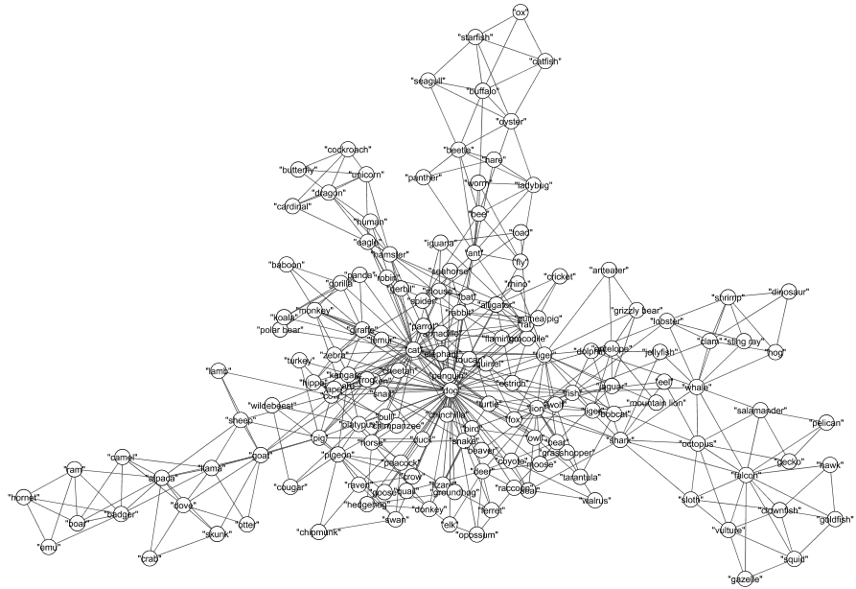
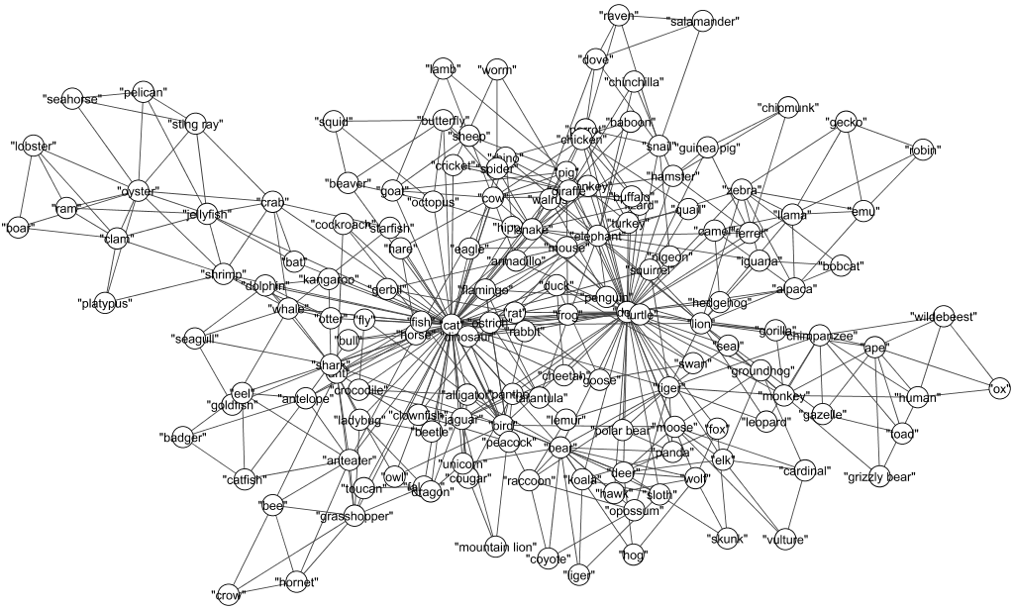
Figure 1. A 2D visualization of the semantic network of the Openness to Experience groups.
Low
High

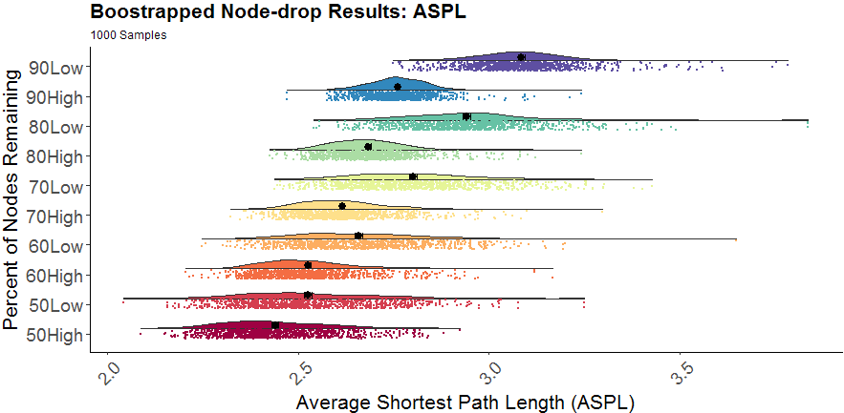
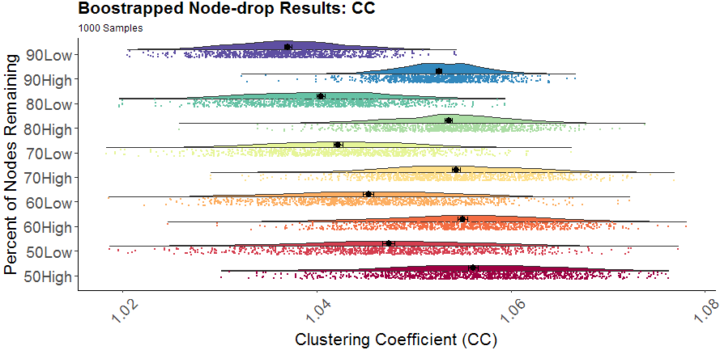
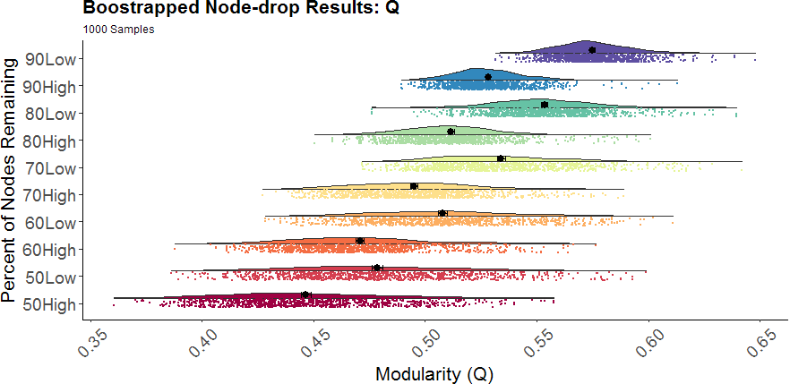
Figure 2. Plots of the bootstrapped partial network measures (1000 samples per nodes remaining percentage). Density plots are above the scatterplots (individual dots depict a single sample), with a black dot representing the mean. The y-axis denotes the Openness to Experience group (high and low) and the percentage of nodes remaining (e.g., 90Low = 90% nodes remaining bootstrapped sample for the low Openness to Experience group).

The most up-to-date version of the SemNetCleaner package can be retrieved from https://github.com/AlexChristensen/SemNetCleaner

